Trip Summary and Drive Cycle (This Trip) Function - PHEV_FHEV - CGEA1.3_v3.2

Functional Description

“Drive Cycle “(This Trip) Function calculates, stores, and displays the trip information at end of a drive cycle. A Drive Cycle Trip starts upon a transition of Operational-Mode from CRANK to NORMAL and ends upon a transition of Operational-Mode into CRANK. There is no customer reset for “This Trip” function.
The Information shall include the following:
- Trip Time
- Trip Average FE.
- Total Distance Driven.
- Trip Electric Vehicle Distance Achieved.

The instrument cluster also calculates, stores, and displays a summary of the trip (Trip summary) at key off. Same ‘This Trip’ information is used to display summary screen.

Note: This STSS is using many parameters from the Fuel Economy STSS, “Fuel Economy (AFE, AFE Histogram, IFE, LT, DC, MyKey) - CGEA1.3 vx.x.doc” and Trip Computer - Timers - CGEA1.3_vx.x.doc.

Interfaces

Interface Context Diagram (I/O Block Diagram)

Trip Consumption Context Diagram

Inputs

IR-REQ-345481/B-Internal:
  - Operational_Mode
  - Display_Units_MC (Parameter is defined as an output in Unit Selection STSS, “Display Unit Selection Control Function - CGEA1.3_vx.x.doc”)
  - Startup_Shutdown_State (Input from Welcome Goodbye Strategy STSS)

Parameters from Fuel Economy STSS, defined as an output in “Fuel Economy (AFE, AFE Histogram, IFE, LT, DC, MyKey) - CGEA1.3_vx.x.doc”:
  - EV_Distance_DC_MC
  - FE_DC_Distance
  - Fuel_Econ_DC
  - ConsUnitIPC_D_Dsply signal is defined as an output in the Fuel Economy STSS. Signal values are evaluated and transmission is handled in the Fuel Economy STSS.

Parameters from Trip Computer Timers STSS, defined as an output in “Trip Computer - Timers - CGEA1.3_vx.x. doc”
  - TCT_Hours_DC_MC
  - TCT_Minutes_DC_MC
  - TCT_Seconds_DC_MC

MUX signals

SIG-REQ-345145/A-ConsUnitIPC_D_Dsply Signal
(IPC transmitted signal. See Fuel Economy STSS)
Signal Name | Size (bits) | Detail | Units | Res. | Offset | State Encoded | Min | Max
ConsUnitIPC_D_Dsply | 8 |  | SED | 1 | 0 |  | 0 (0x0) | 15 (0xF)
 |  | Invalid |  |  |  | 0x0
 |  | MPG (US) |  |  |  | 0x1
 |  | L/100km |  |  |  | 0x2
 |  | km/L |  |  |  | 0x3
 |  | MPG (UK) |  |  |  | 0x4
 |  | Whr / mi |  |  |  | 0x5
 |  | Whr / km |  |  |  | 0x6
 |  | MPG US Equivalent (PHEV) |  |  |  | 0x7
 |  | L/100km Equivalent (PHEV) |  |  |  | 0x8
 |  | km/l Equivalent (PHEV) |  |  |  | 0x9
 |  | MPG UK Equivalent (PHEV) |  |  |  | 0xA
 |  | MPG_v2 |  |  |  | 0xB
 |  | Reserved_12 thru Reserved_15 |  |  |  | 0xC – 0xF
Note: IPC always transmits ConsUnitIPC_D_Dsply as 0XB.

SIG-REQ-345146/A-EngActv_B_Dsply (CAN) Signal

Signal Name | Size (bits) | Detail | Units | Res. | Offset | State Encoded | Min | Max
EngActv_B_Dsply | 1 |  | SED | 1 | 0 |  | 0 (0x0) | 1 (0x1)
 |  | Off |  |  |  | 0x0
 |  | On |  |  |  | 0x1

Outputs

IR-REQ-345856/A-Internal:
  - EV_Distance_DC
  - Total_Distance_DC
  - Energy_Used_DC
  - TCT_Hours_DC
  - TCT_Minutes_DC
  - TCT_Seconds_DC
  - Display_All_Electric_Txt_Flag

MUX signals

SIG-REQ-345147/A-TripSum_L_Dsply Signal

Signal Name | Size (bits) | Detail | Units | Res. | Offset | State Encoded | Min | Max
TripSum_L_Dsply | 16 |  | Km | 0.1 | 0 |  | 0  (0x0) | 6553.3  (0xFFFD)
 |  | No_Data_Available |  |  |  | 0xFFFE
 |  | Faulty |  |  |  | 0xFFFF

SIG-REQ-345148/A-ConsAvgTrip_Fe_Dsply Signal

Signal Name | Size (bits) | Detail | Units | Res. | Offset | State Encoded | Min | Max
ConsAvgTrip_Fe_Dsply | 24 |  | Litre / 100 kilometer | 0.0001 | 0 |  | 0  (0x0) | 1677.7215  (0xFFFFFF)
(Defined in Fuel Economy STSS, Shown here to ensure that this signal is broadcasted when this STSS is used)

Function/Performance

F-REQ-345149/A-Operational Modes

Mode | Differentiating Vehicle Conditions
Sleep Mode | This Trip Function Off
Limited Mode | Trip Summary Function ON (Display, no calculations)
Normal Mode | This Trip Function ON
Crank Mode | This Trip Function ON

Voltage Levels

Refer to Cluster Features table located in Operational Modes and Voltage Range Strategies Section in this SPSS.

Human-Machine Interface

Visual

Indicator Graphics / Display Format
FHEV/PHEV This Trip Screens
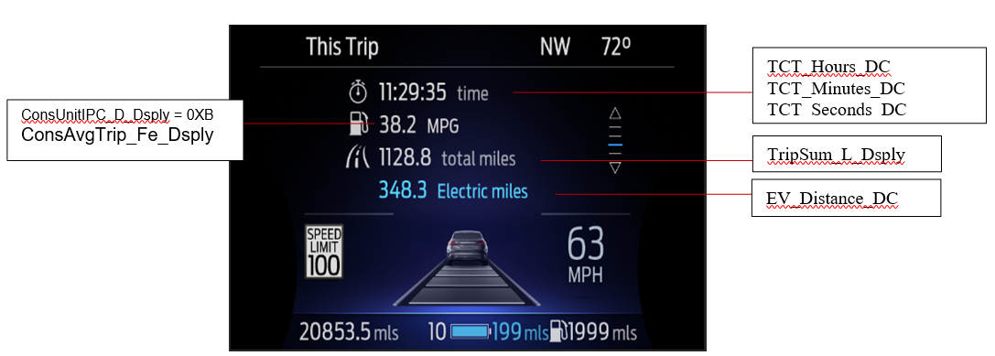

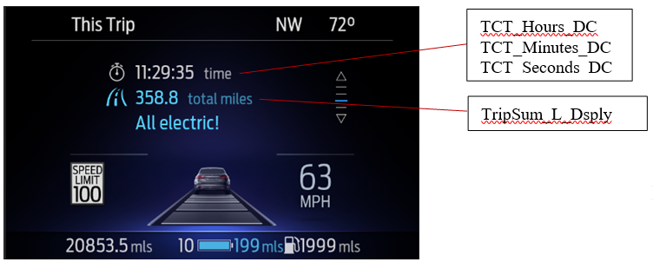

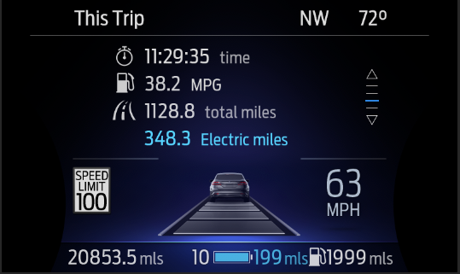
Drop Decimal when above 999.9 for distance to fit the word “Total” for total distance.

Note: Drop Decimal when above 999.9 for distance to fit the word “Total” for total distance. In addition, as shown in graphic examples, Electric Miles display should include decimal digit. Please contact program specific D&R, if there is any space issue in accumulating decimal digit.

FHEV/PHEV ‘Trip Summary’ Screens

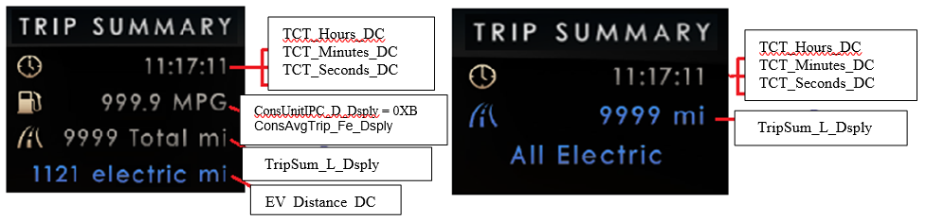

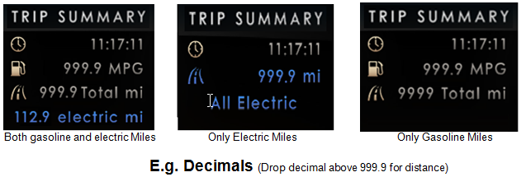

Above are example graphics. Refer to HMI Program for actual symbol definition

All Electric Text ID

I705 – “All Electric”

Message Center Text Warning Message as defined in section 1.3.5.7 of this document. Actual wording may vary based on Program Translation table.

Indicator Color Coordinates

Reference section COLOR & ILLUMINATION REQUIREMENTS (GRAPHICS).

The table below details guidelines for coloring. Consult with the latest HMI files for the latest details.
Data | Gas And Battery Used | No Gas(Only Battery)
Trip Time | Always White | Always White
Energy Used | Always White | NA
Total Distance | Always White | Always Blue
EV Distance | Always Blue | NA
All Electric | NA | Always Blue

Below is an example to show “Trip Summary” and “This Trip” display colors guidelines

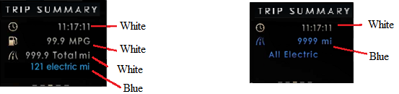

Audio

None

Switch Control Logic

N/A

PFM-REQ-345150/A-System Accuracy
- Within a 100msec of receiving a message/input that results in a change of state the cluster will update the display to the proper status.
- Shall use kilometer to miles conversion constant of 1/1.609344
- Shall use liters to U.S. gallons conversion constant of 1/3.785412
- Shall use U.S. gallons to U.K. gallons conversion constant of 0.8326725

Operation: Performance and Functional

Subsystem Algorithm Flowchart / State Diagram

F-REQ-345151/A-IPC Display Parameter & Transmitted CAN Signal State Matrix

Display Parameter Source | Display Parameter Value | IPC Display Parameter | IPC Transmitted CAN Signal
Fuel Economy SSTS | EV_Distance_DC_MC | EV_Distance_DC | None
Fuel Economy SSTS | FE_DC_Distance | Total_Distance_DC | TripSum_L_Dsply signal
Fuel Economy SSTS | Fuel_Econ_DC | Energy_Used_DC | ConsAvgTrip_No_Dsply signal.
Trip Computer Timers SSTS | TCT_Hours_DC_MC | TCT_Hours_DC | None
Trip Computer Timers SSTS | TCT_Minutes_DC_MC | TCT_Minutes_DC | None
Trip Computer Timers SSTS | TCT_Seconds_DC_MC | TCT_Seconds_DC | None

F-REQ-345152/B-Flowchart for CAN Diagnostic Configuration Routine

F-REQ-345153/B-Subsystem Flowchart for ‘All Electric Driving’ Flag

F-REQ-345154/B-Subsystem Flowchart for Shutdown Screen (Trip Summary)

F-REQ-345155/B-Subsystem Flowchart for ‘This Trip’

Operation Description (supports algorithm flowchart /state diagram)

Distance is displayed in the units chosen, as indicated by Display_Units_MC, which is defined as an output
in “Display Unit Selection Control Function ”

HMI-REQ-345857/A-Display_All_Electric_Txt_Flag to MC IOD Message ID

MC_Status_Flag | Mc IOD - Message ID
Display_All_Electric_Txt_Flag | I705

FS-REQ-345859/A-Function Safety Classification (EMC)

Class B

NVM-REQ-345858/B-Memory Storage

Parameter Name | Description | Value at Battery connect | Value at  Module Wake-up
Display_Units_MC | Parameter is defined as an output in Unit Selection Control Function STSS.  Input to this routine that controls display indicating units to the driver (i.e. when English: miles, mpg; when Metric: km, L/100 km, km/L). Parameter is to be stored in Battery Backed RAM. | Used Stored Value of Display_Unit_  Selection_Cfg  (See Display Unit Selection Control Function STSS) | Do Not Init
FE_DC_Distance | Defined and calculated in Fuel Economy STSS. Variable stored in battery backed memory and used by Message Center for Drive Cycle Trip Distance in units of current M/C display setting. Range from 0.0 to 999.9. | 0 | Do Not Init
Fuel_Econ_DC | Defined and calculated in Fuel Economy STSS. Variable stored in battery backed memory and used by Message Center for Drive Cycle Trip Fuel Economy in units of current M/C display setting. Range from 0.0 to 999.9. | 0 | Do Not Init
EV_Distance_DC_MC | Defined and calculated in Fuel Economy STSS. Variable stored in battery backed memory and used by Message Center for distance traveled under electrical power on the Drive Cycle basis in units of current M/C display setting. Range from 0.0 to 9999.9.. | 0 | Do Not Init
ConsUnitIPC_D_Dsply Signal | Defined as an output in Fuel Economy STSS.  This signal is transmitted by IPC for the consumption units used. See Fuel Economy STSS. | Do Not Init | Do Not Init
Operational_Mode | 4 state indicator for cluster operational mode | Limited | Limited or Normal or Crank
TCT_Hours_This_MC | Defined and calculated in Trip Computer Timers STSS  Integer variable stored in battery backed memory and used by Message Center for This Timer in units of hours. Range from 0 to 9999. | 0 | Do Not Init
TCT_Minutes_This_MC | Defined and calculated in Trip Computer Timers STSS  Integer variable stored in battery backed memory and used by Message Center for This Timer in units of minutes. Range from 0 to 59. | 0 | Do Not Init
TCT_Seconds_This_MC | Defined and calculated in Trip Computer Timers STSS  Integer variable stored in battery backed memory and used by Message Center for This Timer in units of seconds. Range from 0 to 59. | 0 | Do Not Init
Display_All_Electric_Txt_Flag | used to control the message displayed in the message center | Active | Active
EV_Distance_DC | IPC display output for drive cycle EV distance. | 0 | Do Not Init
Regen_Distance_DC | IPC display output for drive cycle Regen distance. | 0 | Do Not Init
Total_Distance_DC | IPC display output for drive cycle total distance driven. | 0 | Do Not Init
Energy_Used_DC | IPC display output for drive cycle fuel economy. | 0 | Do Not Init
TCT_Hours_DC | IPC display output for drive cycle timer in units of Hours | 0 | Do Not Init
TCT_Minutes_DC | IPC display output for drive cycle timer in units of Minutes | 0 | Do Not Init
TCT_Seconds_DC | IPC display output for drive cycle timer in units of Seconds | 0 | Do Not Init
TripSum_L_Dsply Signal | Can signal transmitted by IPC for total drive cycle driven distance. | 0 | Do Not Init
ConsAvgTrip_No_Dsply Signal | Can signal transmitted by IPC for drive cycle equivalent fuel economy for PHEV in units of MPGe. Signal not used (no receiver) on FHEV. | 0 | Do Not Init
GAS_Used_Flag | Used to control All Electric Text flag. It will be true if Engine is ON even once in current Drive Cycle. | False | False
EngActv_B_Dsply | CAN signal used to transmit state of gasoline engine to the cluster | 0 | Do Not Init

Prove Out

No

Reconfigurable Telltale

No

Message Center Msg

I705 – “All Electric”
Refer Warning Message as defined in the Text Message List section of this SPSS

Error Handling

Missing Message Strategy

The signals will be declared missing as per the Diagnostics Section of this SPSS.

DTC states and history will be determined as per the Diagnostics Section of this SPSS.

Invalid Data Strategy

The signals will be declared invalid as per the Diagnostics Section of this SPSS.

DTC states and history will be determined as per the Diagnostics Section of this SPSS.
.

Diagnostics

Self Test

None

Engineering Test Mode

Reference section “Dealer / Engineering Test Mode (ETM)”

Part II Performance

Supported Diagnostic Trouble Codes (DTCs)
As per the Diagnostics Section of this SPSS

DCR-REQ-345855/B-DID DExx

Block  Num | Block Description | Byte(s) | Bits | State: Description | "0" | "1" | Default | Comments/  Information
$01 | Option Content (B&A) |  | 2 | PT Hybrid  0x0 = Non-Hybrid  0x1 = BEV  0x2 = FHEV  0x3 = PHEV |  |  | 0x0 | Default from cluster plant to be 0x0 if cluster can be used on a Non-Hybrid.
$02 | Option Content (B&A) |  |  | Welcome_Goodbye_Cfg | Disabled | Enabled | Disabled | Disabled means the feature is not presented in the vehicle. This cfg bit is typically only disabled on Police vehicles.

Reference Specification

IS-0307 ACCURACY - TRIP DISTANCE (SPEEDOM)
IS-0344 GENERAL REQUIREMENTS (MSGCENTR)
IS-0348 ACCURACY - FUEL USED (MSGCENTR)
IS-0358 ACCURACY – AVERAGE FUEL ECONOMY (MSGCENTR)

HLF_DIDC_v03.09_MY2013_RELEASE_IPC Requirements.pdf

Fuel Economy (AFE, AFE Histogram, IFE, LT, DC, MyKey) - CGEA1.3 vx.x.doc

Operational Modes and Voltage Range Strategies .doc

Display Unit Selection Control Function .doc

Revision History

SPSS Module Revision History

Revision Level | Name | Change Description | Date
1.0 | P Khot | Initial Release based on request from EPE team | 2/20/2017
1.1 | H Sharma | Modifications based on new direction from EPE Team (Dale Gilman)  - Updated section 1.3.3.1.1 “Indicator Graphics / Display Format” for new graphics and updated Decimal strategy.  - Explicit screens are defined for three different conditions in section 1.3.3.1.1 :  - Gas + Electric Miles  - Only Electric  - Only Gas | 09/11/2017
3.0 | H Sharma | This update is based on vehicle testing issue found by EPE team for “All Electric” text flag.  - All Changes are marked in Turquoise color.  - Section 1.3.5.1 is updated for “All Electric” text flag logic for Trip Summary flow charts.  - Section 1.3.5.1 is updated to remove “All Electric” text from This Trip Screen  - New CAN output signal “ConsAvgTrip_Fe_Dsply” is added.  - Section 1.3.3.1.1 is updated to add latest graphics  Examples.  - New CAN signal EngActv_B_Dsply is added to inputs. | 09/20/2018
3.1 | H Sharma | This is a minor update to revert back one change done in previous version (3.0). Changes are marked in Green color.  - Based on inputs from EPE team (Charbel Bouery and Dale Gilman) “All Electric” text is enabled again on ‘This Trip’ Screen if Engine is off during Drive Cycle.  - Figure 5 added for ‘This Trip’ screen update logic. | 10/10/2018
3.2 | H Sharma | This request brought to DICC on 04/04/19 by EPE Team (Charbel Bouery) and approved for STSS update on 04/11/2019.This update is to fix a recent issue found in vehicle testing by EPE team. DICC tracking number #352.  (Initial VSEM Release)  This update is clarification to show decimal digit for electric miles. Although most of HMI examples used in this STSS shows Electric Miles with decimal digit but not mentioned explicitly. So section 1.3.3.1.1 updated to add note to shown decimal digit for Electric miles. Changes are marked in yellow color. | 06/06/2019
3.3 | H. Sharma | This update is performed to resolve flickering issue during welcome state reported by Denso. This issue was introduced due to update in Welcome Goodbye Strategy STSS(v7.5), in which a delay of 200ms added during Welcome transtion. This solution is proposed by Denso to add Startup_Shutdown_State (o/p from Welcome Goodbye Strategy STSS) as input to this STSS and check its state before updating the ‘All Electric’ and ‘Gas Used’ flags. Changes are marked in Orange Color.  - Interface context diagram updated to add inputs from Welcome Goodbye strategy STSS.  - Section 1.2.2.1 IR-REQ-345481/A-Internal is updated to add Startup_Shutdown_State as input  - Section 1.3.5.1.3 F-REQ-345153/A-Subsystem Flowchart for ‘All Electric Driving’ Flag is updated to check outputs from W/F Stss.  - Section 1.3.5.1.4 and 1.3.5.1.5 updated to remove unwanted ‘Yes’ from one branch.  - Section 1.5.3.1 DCR-REQ-345855 is updated to add ‘Welcome_Goodbye_Cfg’. | 06/23/2020

